Streamlining IT Procurement: Automating Standard Laptop Orders with Flow Designer

1. INTRODUCTION

1.1 Project Overview
The project titled “Streamlining IT Procurement: Automating Standard Laptop Orders with Flow Designer” focuses on automating the IT procurement process for standard laptop orders using ServiceNow Flow Designer. In many organizations, laptop procurement involves several manual activities, including submitting requests, obtaining approvals, checking order details, and notifying the relevant departments. These manual processes can lead to delays, repetitive tasks, communication gaps, and errors in order processing.
To overcome these challenges, this project uses ServiceNow Flow Designer to create an automated workflow for handling standard laptop orders. Flow Designer is a low-code automation tool that enables users to design and manage workflows with minimal programming effort. It allows different activities to be connected through triggers, actions, and conditions to ensure that tasks are performed in the correct sequence.
The proposed system aims to simplify the laptop ordering process by automating essential activities such as request initiation, approval routing, order processing, and status notifications. When a user submits a standard laptop order request, the workflow can automatically evaluate the request, route it to the appropriate approver, and proceed with subsequent activities based on the approval outcome. Notifications can also be generated to keep the requester and relevant IT or procurement teams informed about the progress of the order.
By implementing this automated solution, organizations can reduce manual intervention, improve processing efficiency, maintain consistency in procurement activities, and provide better visibility into the status of laptop orders. The project demonstrates how ServiceNow Flow Designer can be used to improve IT service management by transforming a manual procurement process into a structured and automated workflow.

1.2 Purpose
The primary purpose of this project is to streamline and automate the standard laptop procurement process using ServiceNow Flow Designer. The project aims to reduce the time and effort required to process laptop requests while ensuring that approval and procurement activities are handled systematically.
The main objectives of the project are:
1. Automate laptop order requests: Create a structured workflow to manage standard laptop orders from request submission to subsequent processing stages.
2. Simplify the approval process: Automatically route laptop requests to the appropriate approver based on the defined workflow conditions.
3. Reduce manual intervention: Minimize repetitive administrative tasks and reduce the possibility of human errors during request processing.
4. Improve processing efficiency: Establish a consistent workflow that helps reduce delays and ensures that each request follows the required sequence of activities.
5. Enable automated notifications: Inform requesters, approvers, and relevant teams about approval decisions and order status updates through configured notifications.
6. Improve process visibility: Make it easier to track the progress of laptop requests and identify their current processing status.
7. Ensure consistent procurement procedures: Apply standardized rules and conditions to laptop orders so that requests are processed according to organizational requirements.
8. Demonstrate low-code automation: Show how ServiceNow Flow Designer can automate business processes with minimal coding and integrate related activities into a single workflow.
In conclusion, this project aims to establish an efficient, reliable, and standardized approach to IT procurement. By using ServiceNow Flow Designer, the organization can simplify standard laptop ordering, improve coordination between departments, reduce administrative workload, and support faster and more transparent procurement operations.
2. IDEATION PHASE
2.1 Problem Statement
Define the Problem Statements
Date | 31 January 2025
Team ID
Project Name
Maximum Marks | 2 Marks

Customer Problem Statement Template:
Create a problem statement to understand your customer's point of view. The Customer Problem Statement template helps you focus on what matters to create experiences people will love.
A well-articulated customer problem statement allows you and your team to find the ideal solution for the challenges your customers face. Throughout the process, you’ll also be able to empathize with your customers, which helps you better understand how they perceive your product or service.

Reference: https://miro.com/templates/customer-problem-statement/

Example:


Problem Statement (PS) | I am (Customer) | I’m trying to | But | Because | Which makes me feel
PS-1
PS-2

2.2 Empathy Map Canvas

Empathize & Discover

Date | 31 January 2025
Team ID
Project Name
Maximum Marks | 4 Marks

Empathy Map Canvas:
An empathy map is a simple, easy-to-digest visual that captures knowledge about a user’s behaviours and attitudes.

It is a useful tool to helps teams better understand their users.
Creating an effective solution requires understanding the true problem and the person who is experiencing it. The exercise of creating the map helps participants consider things from the user’s perspective along with his or her goals and challenges.
Example:
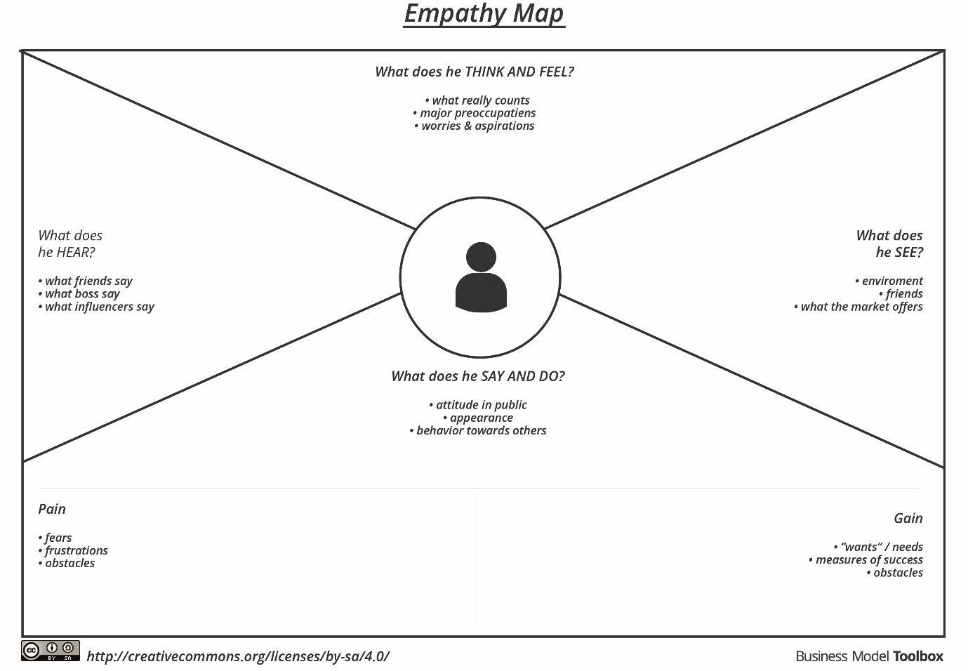

Reference: https://www.mural.co/templates/empathy-map-canvas

Example: Food Ordering & Delivery Application
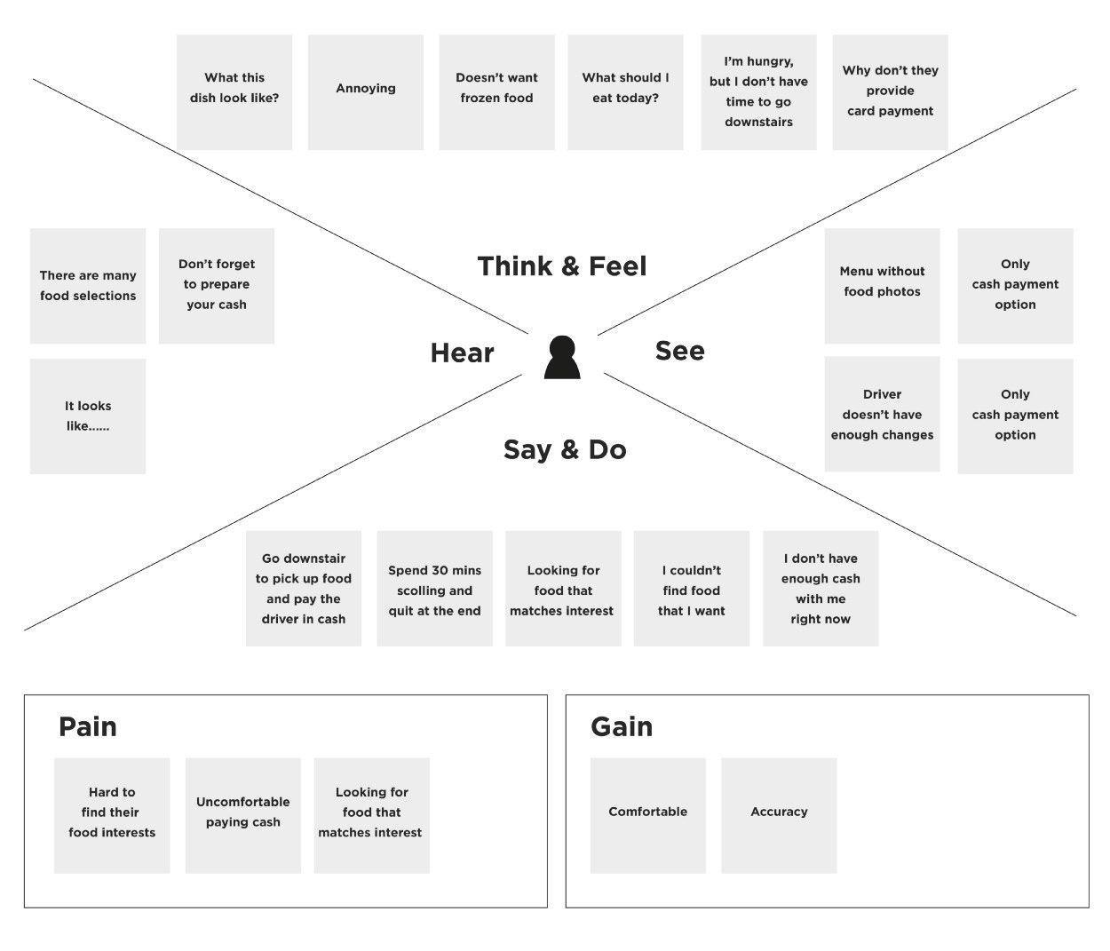

2.3 Brainstorming
Brainstorm & Idea Prioritization Template

Date | 31 January 2025
Team ID
Project Name
Maximum Marks | 4 Marks

Brainstorm & Idea Prioritization Template:
Brainstorming provides a free and open environment that encourages everyone within a team to participate in the creative thinking process that leads to problem solving. Prioritizing volume over value, out-of-the-box ideas are welcome and built upon, and all participants are encouraged to collaborate, helping each other develop a rich amount of creative solutions.
Use this template in your own brainstorming sessions so your team can unleash their imagination and start shaping concepts even if you're not sitting in the same room.
Reference: https://www.mural.co/templates/brainstorm-and-idea-prioritization
Step-1: Team Gathering, Collaboration and Select the Problem Statement


Step-2: Brainstorm, Idea Listing and Grouping


Step-3: Idea Prioritization

3. REQUIREMENT ANALYSIS
3.1 Customer Journey Map
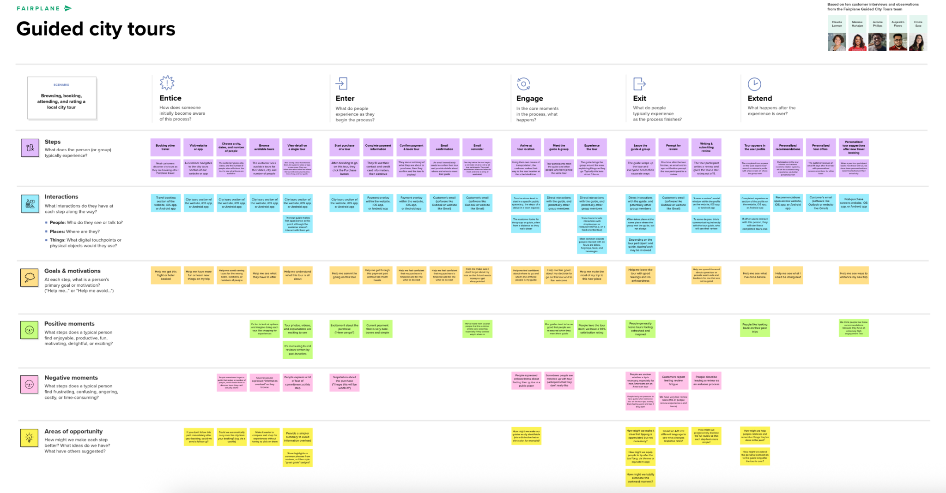
3.2 Solution Requirement
Solution Requirements (Functional & Non-functional)

Date | 31 January 2025
Team ID
Project Name
Maximum Marks | 4 Marks

Functional Requirements:
Following are the functional requirements of the proposed solution.
FR No. | Functional Requirement (Epic) | Sub Requirement (Story / Sub-Task)
FR-1 | User Registration | Registration through Form  Registration through Gmail  Registration through LinkedIN
FR-2 | User Confirmation | Confirmation via Email  Confirmation via OTP
FR-3
FR-4

Non-functional Requirements:
Following are the non-functional requirements of the proposed solution.
FR No. | Non-Functional Requirement | Description
NFR-1 | Usability
NFR-2 | Security
NFR-3 | Reliability
NFR-4 | Performance
NFR-5 | Availability
NFR-6 | Scalability

3.3 Data Flow Diagram
Data Flow Diagram & User Stories

Date | 31 January 2025
Team ID
Project Name
Maximum Marks | 4 Marks

Data Flow Diagrams:
A Data Flow Diagram (DFD) is a traditional visual representation of the information flows within a system. A neat and clear DFD can depict the right amount of the system requirement graphically. It shows how data enters and leaves the system, what changes the information, and where data is store.

Example: (Simplified)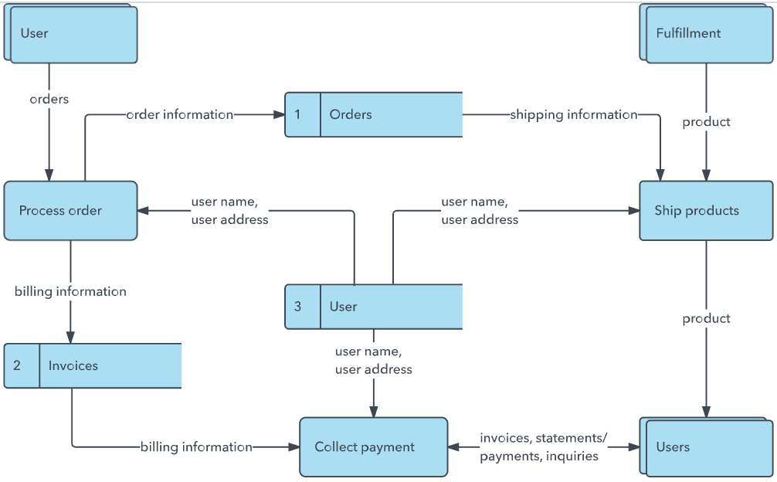
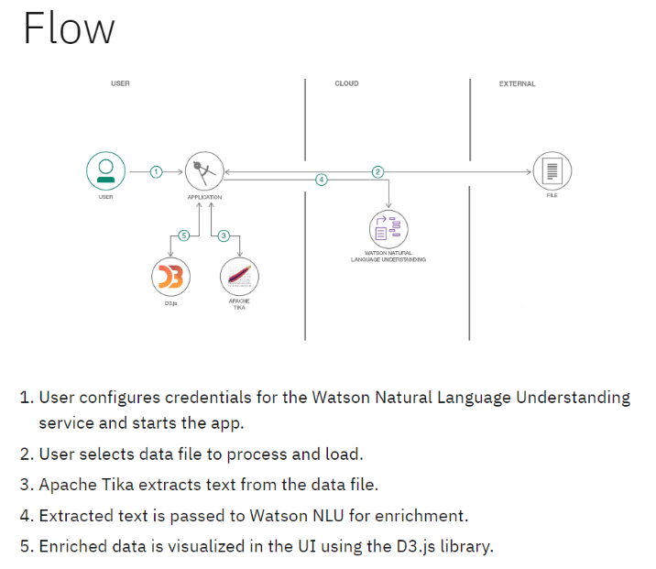

User Stories
Use the below template to list all the user stories for the product.
User Type | Functional Requirement (Epic) | User Story Number | User Story / Task | Acceptance criteria | Priority | Release
Customer (Mobile user) | Registration | USN-1 | As a user, I can register for the application by entering my email, password, and confirming my password. | I can access my account / dashboard | High | Sprint-1
 |  | USN-2 | As a user, I will receive confirmation email once I have registered for the application | I can receive confirmation email & click confirm | High | Sprint-1
 |  | USN-3 | As a user, I can register for the application through Facebook | I can register & access the dashboard with Facebook Login | Low | Sprint-2
 |  | USN-4 | As a user, I can register for the application through Gmail |  | Medium | Sprint-1
 | Login | USN-5 | As a user, I can log into the application by entering email & password |  | High | Sprint-1
 | Dashboard
Customer (Web user)
Customer Care Executive
Administrator

3.4 Technology Stack
Technology Stack (Architecture & Stack)

Date | 31 January 3035
Team ID
Project Name
Maximum Marks | 4 Marks

Technical Architecture:
The Deliverable shall include the architectural diagram as below and the information as per the table1 & table 2

Example: Order processing during pandemics for offline modeReference: 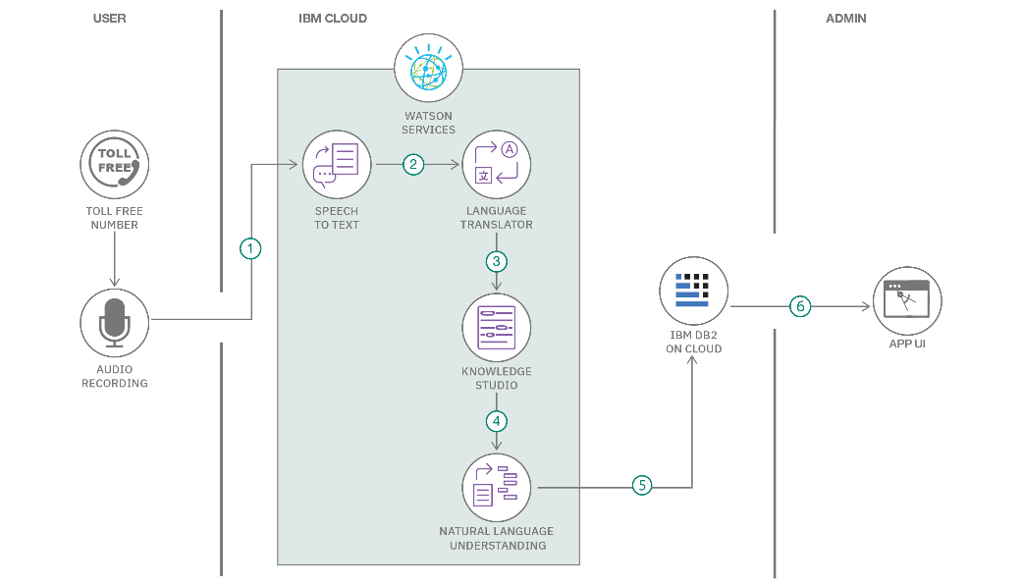
Table-1 : Components & Technologies:
S.No | Component | Description | Technology
 | User Interface | How user interacts with application e.g.  Web UI, Mobile App, Chatbot etc. | HTML, CSS, JavaScript / Angular Js / React Js etc.
 | Application Logic-1 | Logic for a process in the application | Java / Python
 | Application Logic-2 | Logic for a process in the application | IBM Watson STT service
 | Application Logic-3 | Logic for a process in the application | IBM Watson Assistant
 | Database | Data Type, Configurations etc. | MySQL, NoSQL, etc.
 | Cloud Database | Database Service on Cloud | IBM DB2, IBM Cloudant etc.
 | File Storage | File storage requirements | IBM Block Storage or Other Storage Service or Local Filesystem
 | External API-1 | Purpose of External API used in the application | IBM Weather API, etc.
 | External API-2 | Purpose of External API used in the application | Aadhar API, etc.
 | Machine Learning Model | Purpose of Machine Learning Model | Object Recognition Model, etc.
 | Infrastructure (Server / Cloud) | Application Deployment on Local System / Cloud  Local Server Configuration:  Cloud Server Configuration : | Local, Cloud Foundry, Kubernetes, etc.

Table-2: Application Characteristics:
S.No | Characteristics | Description | Technology
 | Open-Source Frameworks | List the open-source frameworks used | Technology of Opensource framework
 | Security Implementations | List all the security / access controls implemented, use of firewalls etc. | e.g. SHA-256, Encryptions, IAM Controls, OWASP etc.
 | Scalable Architecture | Justify the scalability of architecture (3 – tier, Micro-services) | Technology used
 | Availability | Justify the availability of application (e.g. use of load balancers, distributed servers etc.) | Technology used
 | Performance | Design consideration for the performance of the application (number of requests per sec, use of Cache, use of CDN’s) etc. | Technology used

References:
https://c4model.com/
https://developer.ibm.com/patterns/online-order-processing-system-during-pandemic/
https://www.ibm.com/cloud/architecture
https://aws.amazon.com/architecture
https://medium.com/the-internal-startup/how-to-draw-useful-technical-architecture-diagrams-2d20c9fda90d

4. PROJECT DESIGN
4.1 Problem Solution Fit
Problem – Solution Fit Template

Date | 15 February 2025
Team ID
Project Name
Maximum Marks | 2 Marks

Problem – Solution Fit Template:
The Problem-Solution Fit simply means that you have found a problem with your customer and that the solution you have realized for it actually solves the customer’s problem. It helps entrepreneurs, marketers and corporate innovators identify behavioral patterns and recognize what would work and why
Purpose:
- Solve complex problems in a way that fits the state of your customers.
- Succeed faster and increase your solution adoption by tapping into existing mediums and channels of behavior.
- Sharpen your communication and marketing strategy with the right triggers and messaging.
- Increase touch-points with your company by finding the right problem-behavior fit and building trust by solving frequent annoyances, or urgent or costly problems.
- Understand the existing situation in order to improve it for your target group.

Template:

References:
- https://www.ideahackers.network/problem-solution-fit-canvas/
- https://medium.com/@epicantus/problem-solution-fit-canvas-aa3dd59cb4fe

4.2 Proposed Solution
Proposed Solution Template

Date | 15 February 2025
Team ID
Project Name
Maximum Marks | 2 Marks

Proposed Solution Template:
Project team shall fill the following information in the proposed solution template.
S.No. | Parameter | Description
 | Problem Statement (Problem to be solved)
 | Idea / Solution description
 | Novelty / Uniqueness
 | Social Impact / Customer Satisfaction
 | Business Model (Revenue Model)
 | Scalability of the Solution

4.3 Solution Architecture
Solution Architecture
Date | 15 February 2025
Team ID
Project Name
Maximum Marks | 4 Marks

Solution Architecture:
Solution architecture is a complex process – with many sub-processes – that bridges the gap between business problems and technology solutions. Its goals are to:
- Find the best tech solution to solve existing business problems.
- Describe the structure, characteristics, behavior, and other aspects of the software to project stakeholders.
- Define features, development phases, and solution requirements.
- Provide specifications according to which the solution is defined, managed, and delivered.

Example - Solution Architecture Diagram:

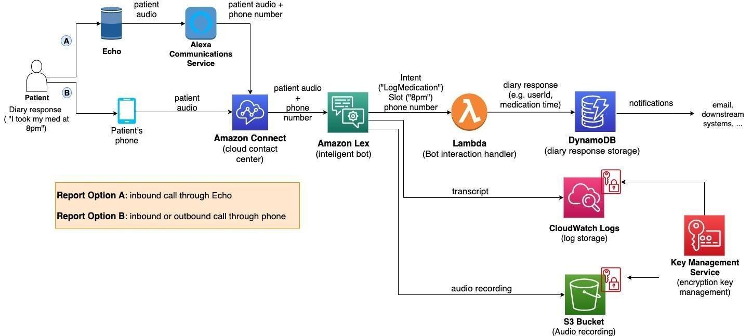
Figure 1: Architecture and data flow of the voice patient diary sample application
Reference: https://aws.amazon.com/blogs/industries/voice-applications-in-clinical-research-powered-by-ai-on-aws-part-1-architecture-and-design-considerations/

5. PROJECT PLANNING & SCHEDULING
5.1 Project Planning

Planning logic
A Sprint fixed period or duration in which a team works to complete a set of tasks
An Epic is a big task or project that is too large to complete in one sprint. It is broken down into smaller tasks (stories) that can be completed over multiple sprints.
A Story is a small task . It is part of an Epic.
A Story Point is a number that represents how much effort a story takes to complete. (usually in form of Fibonacci series)
- Very Easy task
- Normal task
- Moderate task
- Difficult task

Storypoint -5 (1,2,3,5)

Sprint 1
Data Collection (Epic 1)
Gathering Data (USN1) 2
Loading Data(USN2) 1
Data Preparation (Epic 2)
Handling Missing Values(USN3) 3
Creating Fields(USN4)3
Handling Inconsistency in Data(USN5)3
Total Story Point in Sprint 1= 2+1+3+3+3=12

Sprint 2
Data Visualization (Epic 3)
Bar Chart(USN6) 2
Pie Chart(USN7) 2
Line Chart(USN8) 2
Map(USN9) 4

Dashboard (Epic 4)
Developing Dashboard(USN10) 5
Story (Epic 5)
Developing Story(USN11) 5

Total story Point in Sprint 2= 2+2+2+4+5+5=20

Total Story Points
Sprint 1 = 12
Sprint 2 = 20

Velocity= Total Story Points Completed​/ Number of Sprints
Total story Points= 12+20=32
No of Sprints= 2
Velocity =32/2
16(Story Points per Sprint)
Your team’s velocity is 16 Story Points per Sprint.
Project Planning Template (Product Backlog, Sprint Planning, Stories, Story points)

Date | 15 February 2025
Team ID
Project Name
Maximum Marks | 5 Marks

Product Backlog, Sprint Schedule, and Estimation (4 Marks)
Use the below template to create product backlog and sprint schedule
Sprint | Functional Requirement (Epic) | User Story Number | User Story / Task | Story Points | Priority | Team Members
Sprint-1 | Registration | USN-1 | As a user, I can register for the application by entering my email, password, and confirming my password. | 2 | High
Sprint-1 |  | USN-2 | As a user, I will receive confirmation email once I have registered for the application | 1 | High
Sprint-2 |  | USN-3 | As a user, I can register for the application through Facebook | 2 | Low
Sprint-1 |  | USN-4 | As a user, I can register for the application through Gmail | 2 | Medium
Sprint-1 | Login | USN-5 | As a user, I can log into the application by entering email & password | 1 | High
 | Dashboard

Project Tracker, Velocity & Burndown Chart: (4 Marks)
Sprint | Total Story Points | Duration | Sprint Start Date | Sprint End Date (Planned) | Story Points Completed (as on Planned End Date) | Sprint Release Date (Actual)
Sprint-1 | 20 | 6 Days | 24 Oct 2022 | 29 Oct 2022 | 20 | 29 Oct 2022
Sprint-2 | 20 | 6 Days | 31 Oct 2022 | 05 Nov 2022
Sprint-3 | 20 | 6 Days | 07 Nov 2022 | 12 Nov 2022
Sprint-4 | 20 | 6 Days | 14 Nov 2022 | 19 Nov 2022

Velocity:
Imagine we have a 10-day sprint duration, and the velocity of the team is 20 (points per sprint). Let’s calculate the team’s average velocity (AV) per iteration unit (story points per day)

Burndown Chart:
A burn down chart is a graphical representation of work left to do versus time. It is often used in agile software development methodologies such as Scrum. However, burn down charts can be applied to any project containing measurable progress over time.

https://www.visual-paradigm.com/scrum/scrum-burndown-chart/
https://www.atlassian.com/agile/tutorials/burndown-charts

Reference:
https://www.atlassian.com/agile/project-management
https://www.atlassian.com/agile/tutorials/how-to-do-scrum-with-jira-software
https://www.atlassian.com/agile/tutorials/epics
https://www.atlassian.com/agile/tutorials/sprints
https://www.atlassian.com/agile/project-management/estimation
https://www.atlassian.com/agile/tutorials/burndown-charts

6. FUNCTIONAL AND PERFORMANCE TESTING
6.1 Performance Testing
Model Performance Test

Date | 10 February 2025
Team ID | PNT2022TMIDxxxxxx
Project Name | Project - xxx
Maximum Marks

Model Performance Testing:
Project team shall fill the following information in model performance testing template.
S.No. | Parameter | Values | Screenshot
 | Model Summary | -
 | Accuracy | Training Accuracy -  Validation Accuracy -
3. | Fine Tunning Result( if Done) | Validation Accuracy -

Functional & Performance Testing Template
Model Performance Test

Date | 21 February 2025
Team ID | PNT2022TMIDxxxxxx
Project Name | Project - xxx
Maximum Marks

Test Scenarios & Results
Test Case ID | Scenario (What to test) | Test Steps (How to test) | Expected Result | Actual Result | Pass/Fail
FT-01 | Text Input Validation (e.g., topic, job title) | Enter valid and invalid text in input fields | Valid inputs accepted, errors for invalid inputs
FT-02 | Number Input Validation (e.g., word count, size, rooms) | Enter numbers within and outside the valid range | Accepts valid values, shows error for out-of-range
FT-03 | Content Generation (e.g., blog, resume, design idea) | Provide complete inputs and click "Generate" | Correct content is generated based on input
FT-04 | API Connection Check | Check if API key is correct and model responds | API responds successfully
PT-01 | Response Time Test | Use a timer to check content generation time | Should be under 3 seconds
PT-02 | API Speed Test | Send multiple API calls at the same time | API should not slow down
PT-03 | File Upload Load Test (e.g., PDFs) | Upload multiple PDFs and check processing | Should work smoothly without crashing

Model Performance Test

Date | 10 February 2025
Team ID | PNT2022TMIDxxxxxx
Project Name | Project - xxx
Maximum Marks | 10 Marks

Model Performance Testing:
Project team shall fill the following information in model performance testing template.
S.No. | Parameter | Values | Screenshot
 | Metrics | Regression Model:  MAE - , MSE - , RMSE - , R2 score -  Classification Model:  Confusion Matrix - , Accuray Score- & Classification Report -
 | Tune the Model | Hyperparameter Tuning -  Validation Method -

Model Performance Test

Date | 10 February 2025
Team ID | PNT2022TMIDxxxxxx
Project Name | Project - xxx
Maximum Marks

Model Performance Testing:
Project team shall fill the following information in model performance testing template.
S.No. | Parameter | Screenshot / Values
 | Data Rendered
 | Data Preprocessing
3. | Utilization of Data Filters
4. | DAX Queries Used
5. | Dashboard design | No of Visualizations / Graphs -
6 | Report Design | No of Visualizations / Graphs -

Model Performance Test

Date | 21 February 2025
Team ID | PNT2022TMIDxxxxxx
Project Name | Project - xxx
Maximum Marks

Model Performance Testing:
Project team shall fill the following information in model performance testing template.
S.No. | Parameter | Values | Screenshot
 | Model Summary | Salesforce automation setup for Data management using Object, Fields and Reports.  Note : Import Records if data Match Correctly then Records will Created or Else it will Show Error | 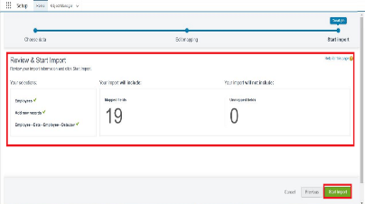
 | Accuracy | Training Accuracy - 98%  Validation Accuracy - 98% | - 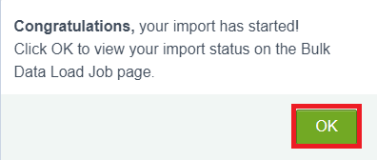
3. | Confidence Score (Only Yolo Projects) | Class Detected - If detecting Object and fields name if wrong and other activity  Confidence Score - If the model is 92% sure the object is correctly detected | 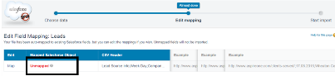  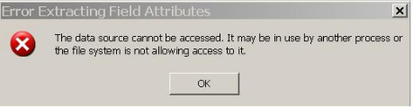

Performance Test

Date | 10 February 2025
Team ID | PNT2022TMIDxxxxxx
Project Name | Project - xxx
Maximum Marks

Model Performance Testing:
Project team shall fill the following information in model performance testing template.
S.No. | Parameter | Screenshot / Values
 | Data Rendered
 | Data Preprocessing
3. | Utilization of Filters
4. | Calculation fields Used
5. | Dashboard design | No of Visualizations / Graphs -
6 | Story Design | No of Visualizations / Graphs -
User Acceptance Testing (UAT) Template
Date
Team ID
Project Name
Maximum Marks

Project Overview:
Project Name: [Enter Project Name]
Project Description: [Brief Description of the Project]
Project Version: [Version Number]
Testing Period: [Start Date] to [End Date]
Testing Scope:
[List of Features and Functionalities to be Tested]
[List of User Stories or Requirements to be Tested]
Testing Environment:
URL/Location: [Web URL or Application Location]
Credentials (if required): [Username/Password]
Test Cases:
Test Case ID | Test Scenario | Test Steps | Expected Result | Actual Result | Pass/Fail
TC-001 | [Describe the scenario to be tested] | [Step 1]  [Step 2]  [Step 3] | [Describe the expected outcome] | [Record the actual outcome] | [Pass/Fail]
... | ... | ... | ... | ... | ...

Bug Tracking:
Bug ID | Bug Description | Steps to reproduce | Severity | Status | Additional feedback
BG-001 | [Describe the issue or bug encountered] | [Step 1]  [Step 2]  [Step 3] | [Low/Medium/High] | [Open/In Progress/Closed] | [Any additional comments or feedback]
... | ... | ... | ... | ... | ...

Sign-off:
Tester Name: [Name of Tester]
Date: [Date of Test Completion]
Signature: [Tester's Signature]
Notes:
- Ensure that all test cases cover both positive and negative scenarios.
- Encourage testers to provide detailed feedback, including any suggestions for improvement.
- Bug tracking should include details such as severity, status, and steps to reproduce.
- Obtain sign-off from both the project manager and product owner before proceeding with deployment.
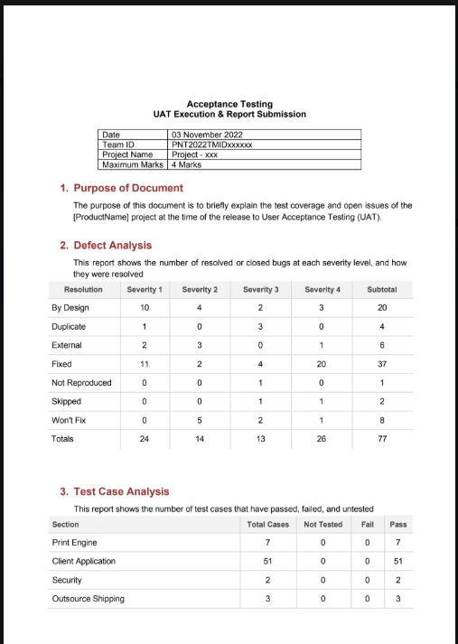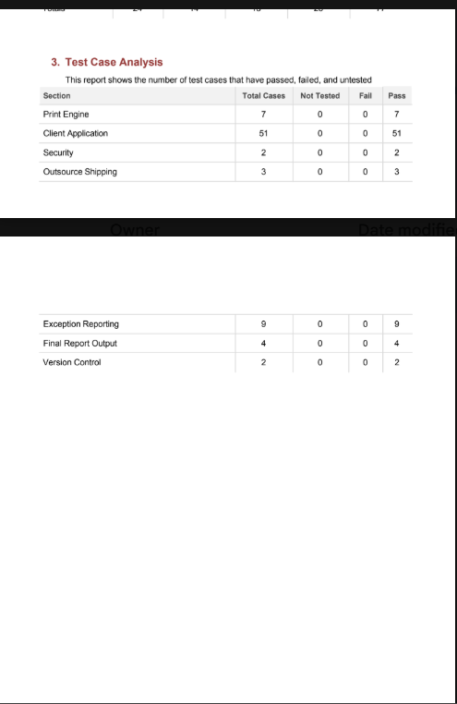

7. RESULTS
7.1 Output Screenshots
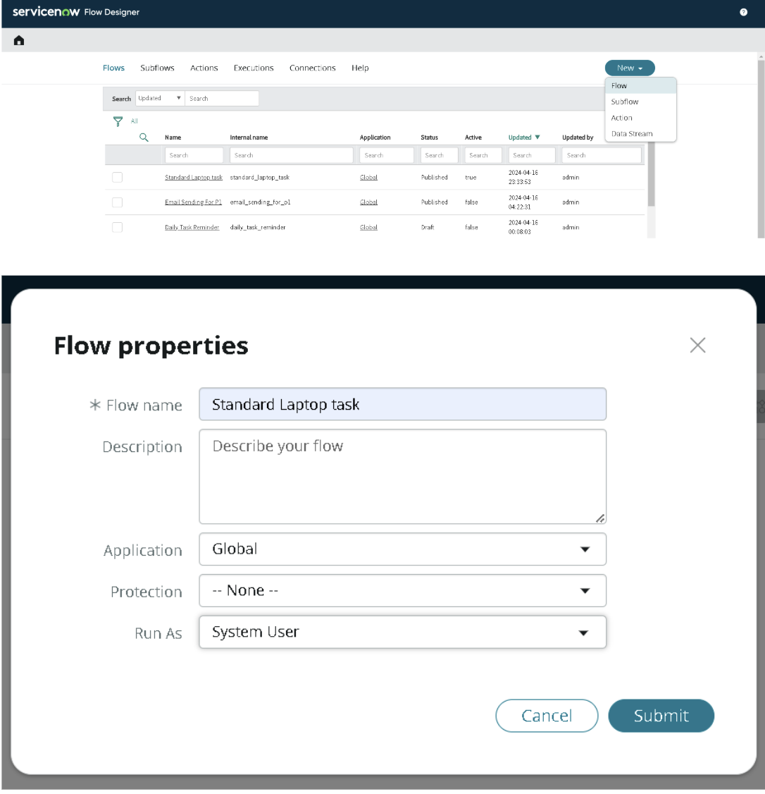
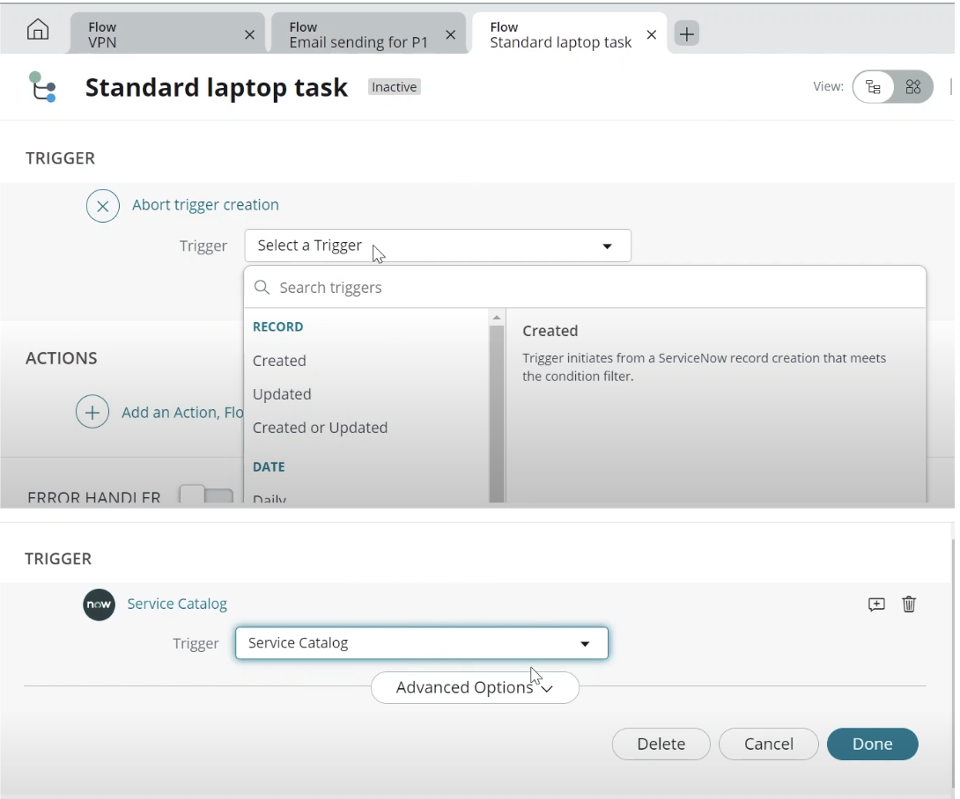
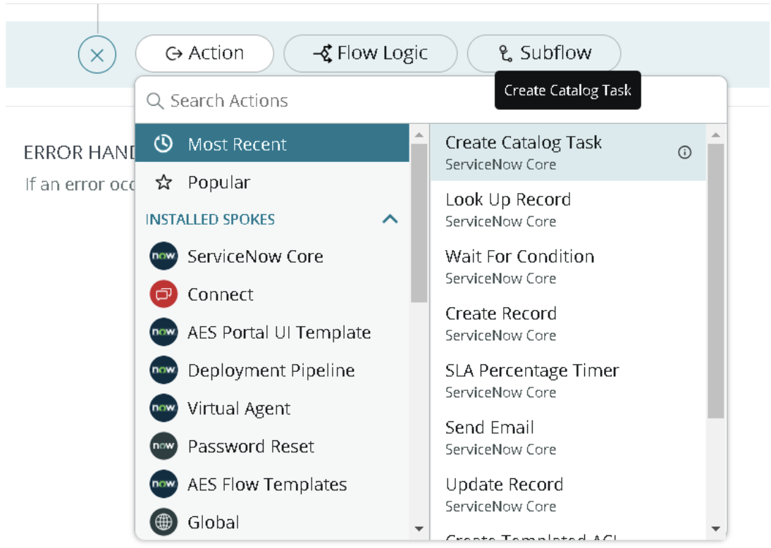

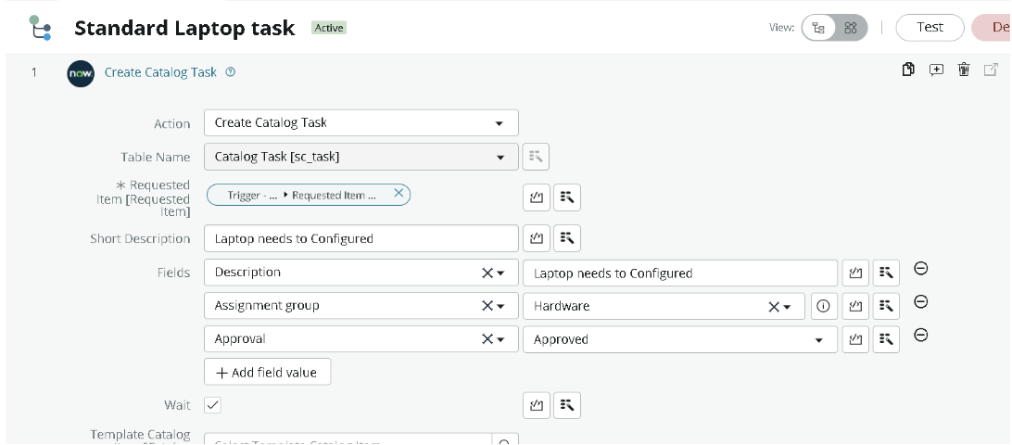
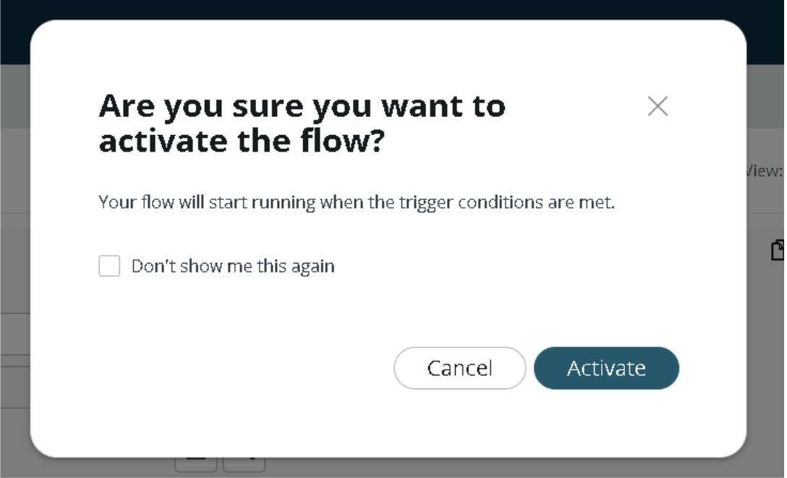

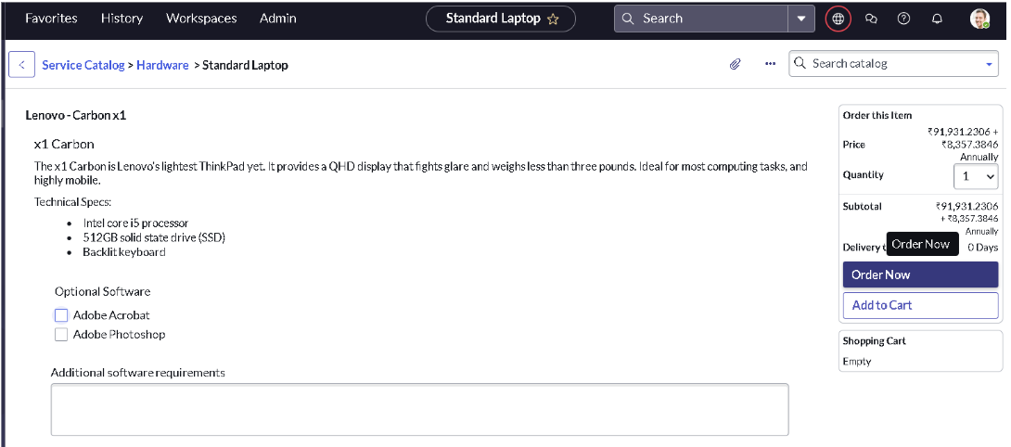
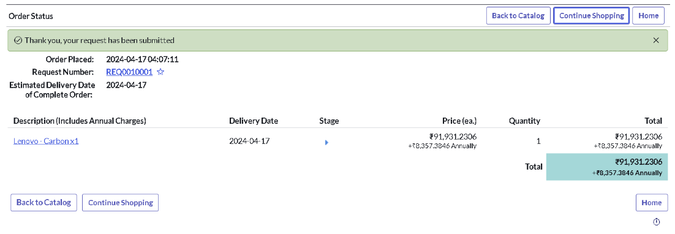

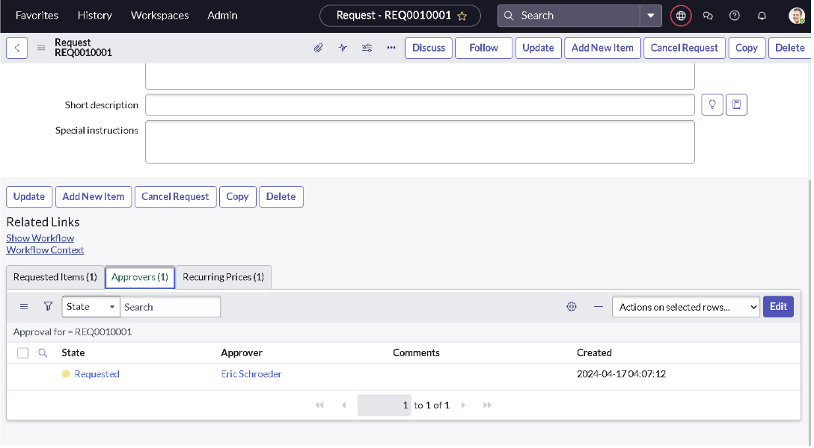
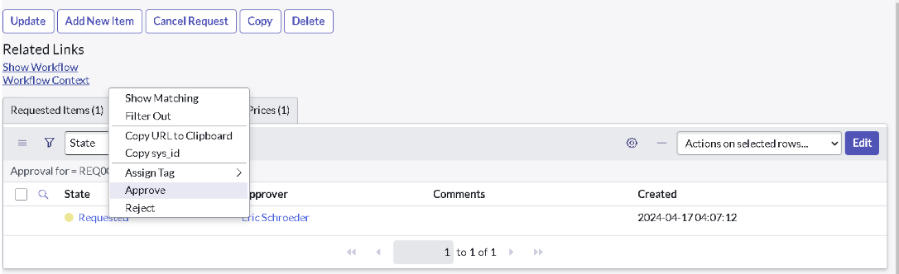
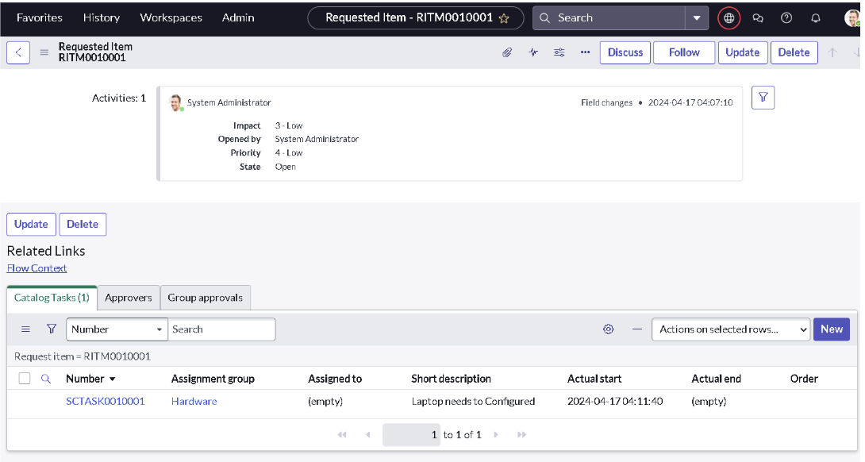
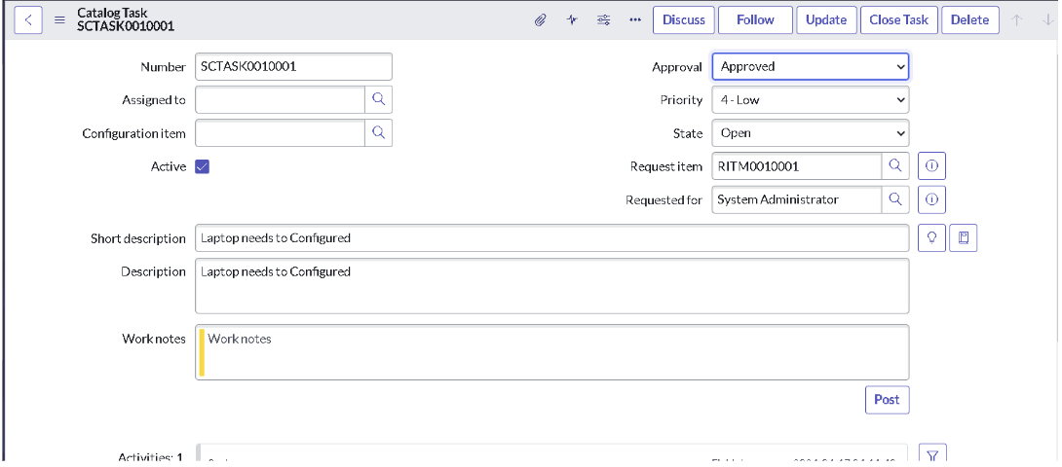

8. ADVANTAGES & DISADVANTAGES

8.1 Advantages
The project “Streamlining IT Procurement: Automating Standard Laptop Orders with Flow Designer” provides several advantages by automating the standard laptop ordering process using ServiceNow Flow Designer.
1. Reduces Manual Work: Automation reduces the need for employees to perform repetitive tasks manually, such as routing requests and sending status notifications.
2. Faster Request Processing: Automated workflows help process laptop requests more efficiently by moving requests through predefined stages without unnecessary delays.
3. Improved Accuracy: Standardized workflow conditions help minimize human errors and ensure that requests are processed according to predefined rules.
4. Automated Approval Management: Laptop requests can be automatically routed to the appropriate approvers, making the approval process more organized and efficient.
5. Better Communication: Automated notifications keep requesters, approvers, and IT procurement teams informed about request progress and approval decisions.
6. Improved Transparency: The workflow allows users and authorized teams to monitor request statuses and understand the progress of each order.
7. Increased Productivity: IT and procurement employees can focus on more important responsibilities instead of spending time on repetitive administrative activities.
8. Low-Code Development: ServiceNow Flow Designer provides a visual interface for designing workflows with minimal programming knowledge.
9. Standardized Process: Every laptop request can follow the same predefined process, ensuring consistency across the organization.
10. Easy Maintenance: Workflow conditions and actions can be modified when procurement policies or organizational requirements change.

8.2 Disadvantages
Although the proposed system provides several benefits, it also has certain limitations.
1. Initial Configuration Effort: Designing and configuring the workflow requires time, planning, and knowledge of the ServiceNow platform.
2. Platform Dependency: The automation depends on ServiceNow and its availability. Platform outages or technical issues may interrupt workflow execution.
3. Limited Flexibility for Complex Requests: Standard workflows may require additional conditions or custom development to handle unusual laptop requests or special procurement requirements.
4. Integration Requirements: Connecting the workflow with external procurement, inventory, or financial systems may require additional configuration and integration.
5. Maintenance Requirements: The workflow must be reviewed and updated whenever organizational policies, approval rules, or system configurations change.
6. User Training: Employees and administrators may require training to understand the request process and use the ServiceNow system effectively.
7. Configuration Errors: Incorrectly configured triggers, conditions, approvals, or actions may cause requests to be delayed or processed incorrectly.
8. Access and Security Management: Appropriate user roles and permissions must be configured to prevent unauthorized access to procurement requests and related information.
Despite these limitations, proper configuration, testing, security controls, and regular maintenance can help ensure that the automated procurement workflow operates effectively.

9. CONCLUSION
The project “Streamlining IT Procurement: Automating Standard Laptop Orders with Flow Designer” demonstrates how ServiceNow Flow Designer can be used to simplify and automate the IT procurement process. The project focuses on improving the handling of standard laptop orders by reducing manual activities and introducing a structured workflow for request processing.
By using Flow Designer, different stages of the procurement process, such as request initiation, approval routing, status updates, and notifications, can be connected through predefined triggers, conditions, and actions. This approach helps maintain consistency and improves coordination between requesters, approvers, and IT procurement teams.
The automated workflow can reduce repetitive administrative tasks, minimize human errors, improve processing efficiency, and provide better visibility into the status of laptop requests. Furthermore, the low-code capabilities of ServiceNow Flow Designer make it easier to create, manage, and modify workflows according to organizational requirements.
The project also highlights the importance of workflow automation in modern IT service management. By replacing selected manual activities with automated processes, organizations can improve productivity and establish a more reliable and transparent procurement system.
In conclusion, automating standard laptop orders with ServiceNow Flow Designer provides a systematic approach to IT procurement. With proper configuration, testing, and maintenance, the solution can support faster request handling, improved operational efficiency, and better management of IT resources.

10. FUTURE SCOPE
The proposed project can be enhanced in the future by incorporating additional features and integrations to make the IT procurement process more intelligent, efficient, and comprehensive.
1. Integration with Inventory Management: The workflow can be integrated with an inventory management system to check laptop availability before processing an order. This can help prevent requests for unavailable devices.
2. Automated Purchase Order Generation: The system can be extended to generate purchase orders automatically after the required approvals are completed.
3. AI-Based Request Processing: Artificial intelligence can be incorporated to classify requests, identify unusual ordering patterns, and recommend suitable laptop configurations based on user requirements.
4. Advanced Approval Rules: Additional approval conditions can be introduced based on laptop cost, employee role, department, budget limits, or organizational policies.
5. Real-Time Notifications: The system can provide timely notifications through email or other supported communication channels to inform users about approval decisions, procurement progress, and delivery updates.
6. Procurement Dashboard and Reports: A dashboard can be developed to display the number of requests, pending approvals, completed orders, rejected requests, and average processing time. These reports can help management monitor procurement performance.
7. Supplier Management Integration: The workflow can be connected with supplier management systems to support vendor selection, price comparisons, order placement, and delivery tracking.
8. Budget Validation: The system can be enhanced to verify available departmental budgets before forwarding laptop requests for final approval.
9. Automated Escalation: Pending approvals can be escalated to higher authorities when they exceed predefined time limits, helping reduce unnecessary delays.
10. End-to-End Procurement Automation: The solution can be expanded to cover the complete procurement lifecycle, including request submission, approval, purchasing, delivery tracking, asset registration, and employee assignment.
11. Mobile Accessibility: The workflow can be made easier to access through supported mobile interfaces, allowing employees and approvers to submit requests and review approvals while away from their desks.
12. Enhanced Security and Auditing: Additional access controls, audit records, and monitoring mechanisms can be implemented to improve security and support compliance with organizational policies.
In the future, these enhancements could transform the proposed workflow into a comprehensive IT procurement automation solution. By integrating inventory management, supplier systems, reporting tools, and intelligent automation, organizations can further reduce manual effort, improve decision-making, and manage IT assets more effectively.
11. APPENDIX
GitHub:
ProjectDemoLink:

